3.3 Awards and Special Recognition

Gloria Barron Prize for Young Heroes Honoree- Student Reed Spaulding | October 2022 | Won for efforts in environmental sustainability through the Tributary Festival, Club, and 501(c)(3).  Below is the news article for the award.
Governor’s Service Award Youth Winner- Student Reed Spaulding | November 2022 | Sole winner of the Governor’s Service Award in the Youth Category for the student-led music festival, the Tributary Festival. Below is more information about the award.
Green60 Winner | May 2021 | Countywide initiative to get students more involved in taking care of their local environment. All students within BCPS are invited to participate and can points for completing various activities like trash pickups, artwork, PSA, group enviro initiatives. Towson High was one of the 3 high schools that won.
Maryland Department of Environment – Participant in “Rethink Recycling” | November 2022  November 2021  November  2019  November 2018  November 2017 | America Recycles Day (ARD) is a national event (November 15th) that promotes recycling, source reduction, and buying products made from recycled materials as objectives to a more sustainable society. In celebration of ARD, MDE has created the “Rethink Recycling” sculpture contest and judging ceremony to display students’ creativity and promote recycling. The sculpture contest and judging ceremony is a great opportunity for celebrating the efforts of the student artists, for media exposure and for promoting waste prevention to the general public. The sculpture contest challenges students to innovatively and artistically use recycled materials as a solution to waste reduction. If you would like more information about ARD, visit the America Recycles Day's web page.
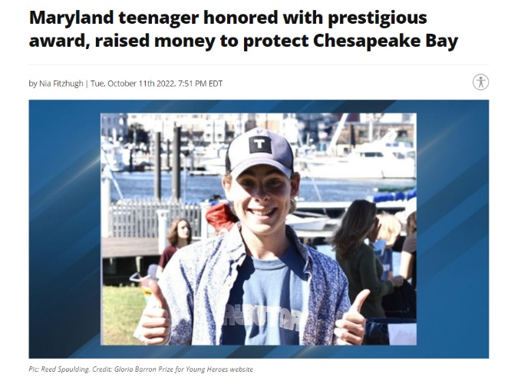
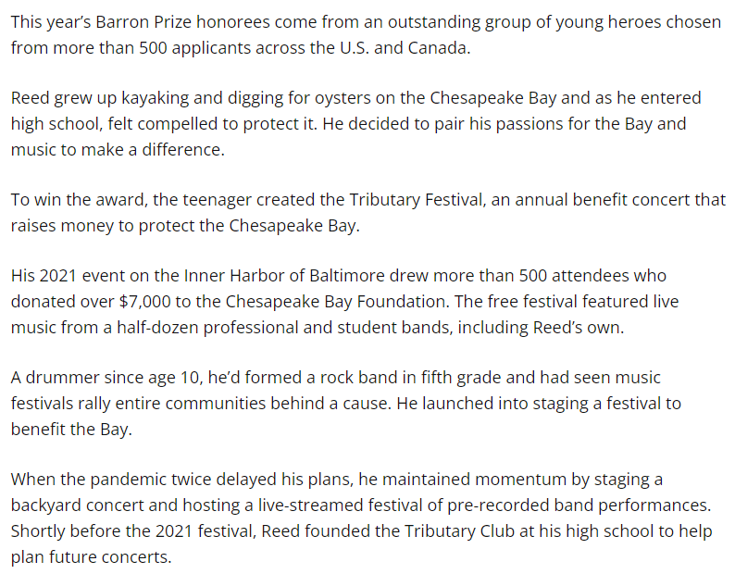
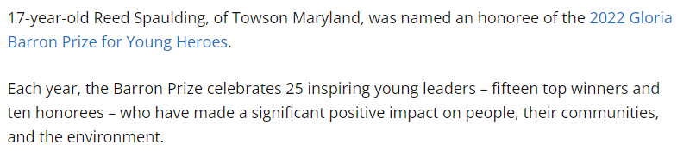
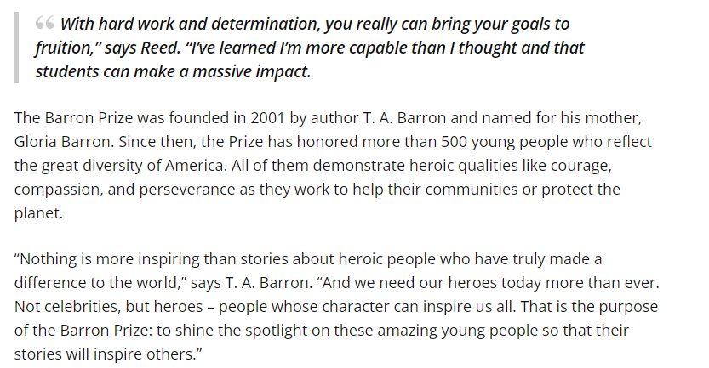
Gloria Barron Prize for Young Heroes Honoree-
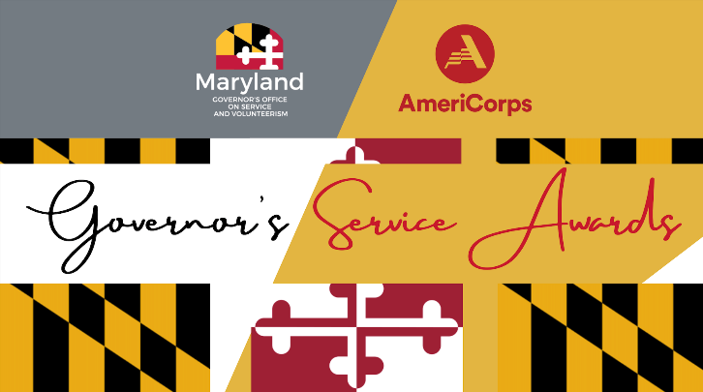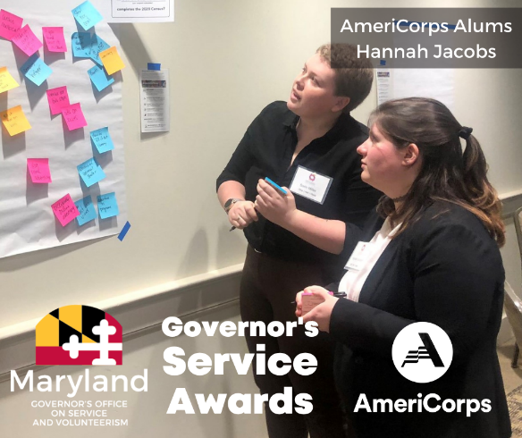
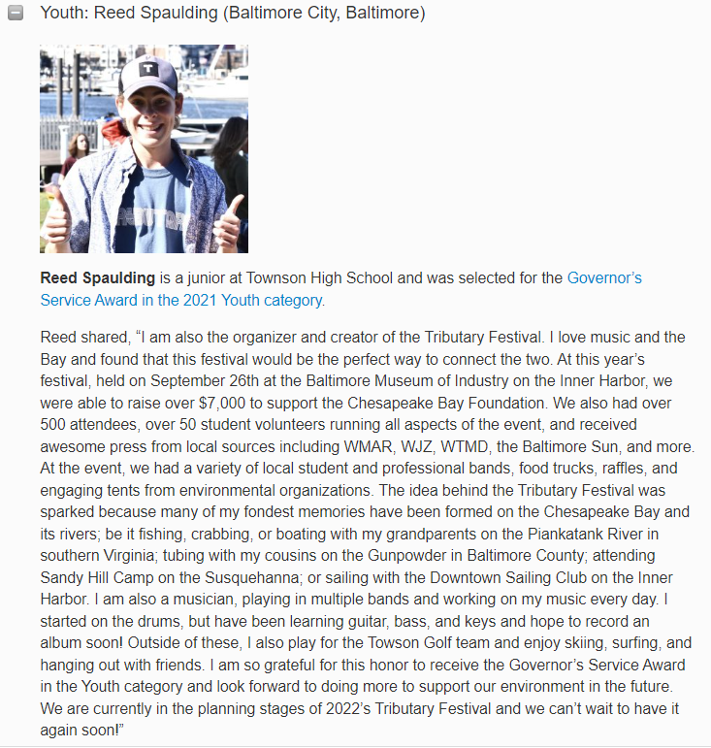
Governor’s Service Award Youth Winner

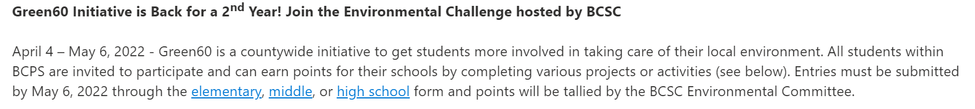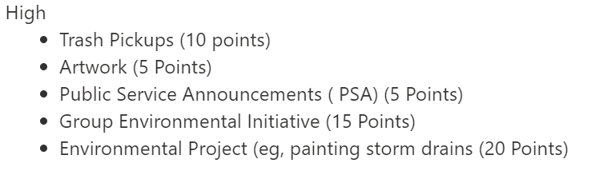
Green60 Winner
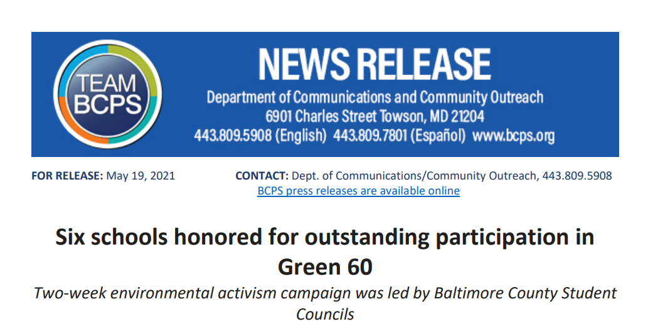
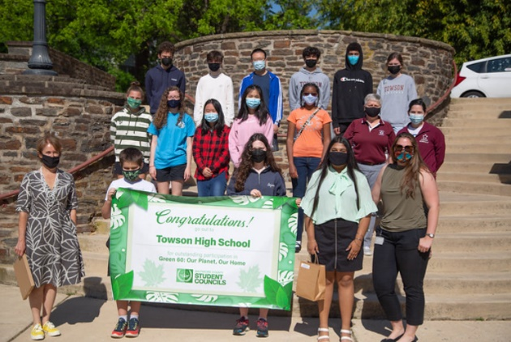
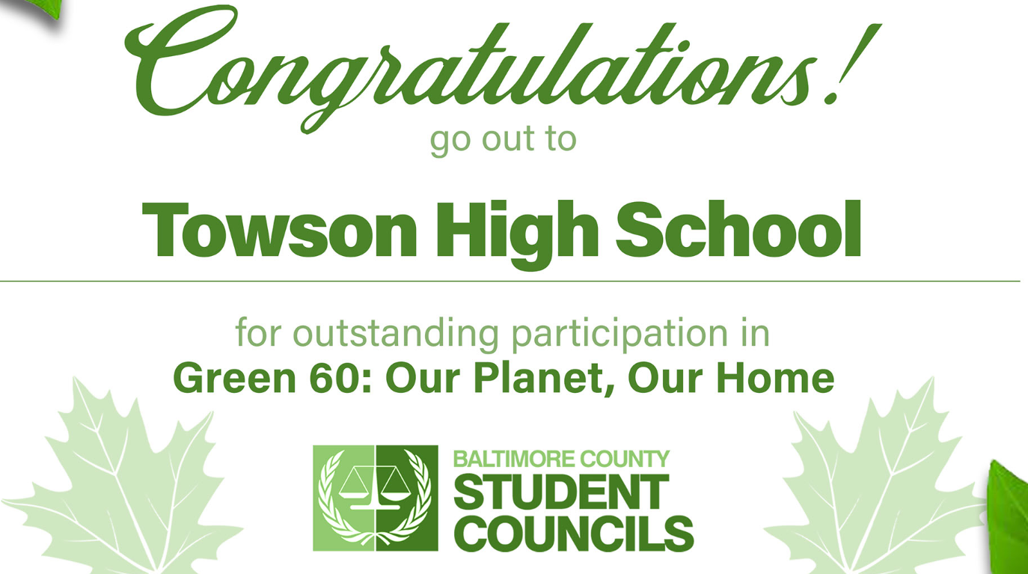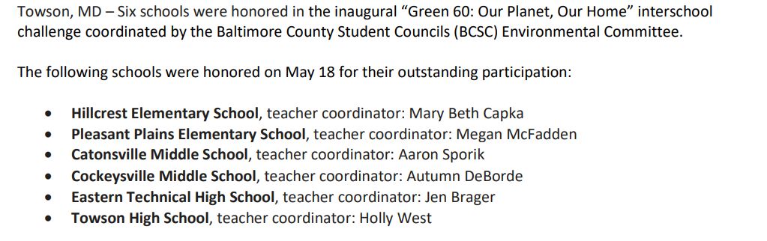
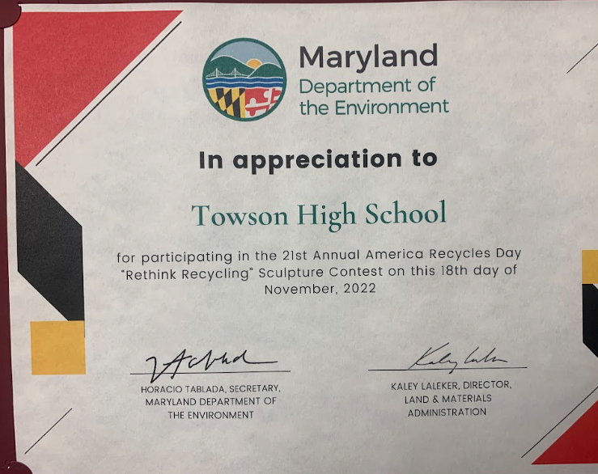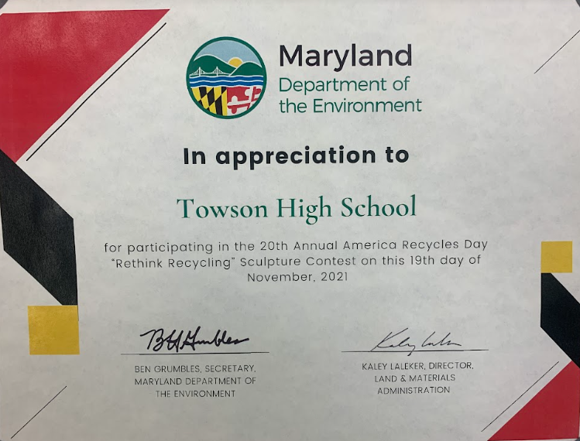
Rethink Recycling
